Bench Tapping Machine

Tapping is the process used to make screw threads in a work-piece. It is also known as internal threading. The tap is used to cut out the female portion of the threading pair or the nut part. This is a widely used industrial process used in fabrication wherever there is a need for a screw. Manual tapping usually is not perpendicularly aligned and leads to improperly aligned for a perfect screw threading. So here we propose a bench tapping machine that delivers accurate tapping functionality by consuming a small amount of space for accurate tapping results. The machine is a shaft driven machine that consists of a strong frame to hold the tapping shaft in place. The shaft is rotated through a smooth bearing mechanism for easy operation. The shaft tip is fitted with a tap holder. The holder can be mounted with taps as and when desired. The machine bed consists of a work piece holder in order to hold it in place for tapping. This machine allows for accurate tapping results for perfectly aligned screw threads.

Block Diagram:

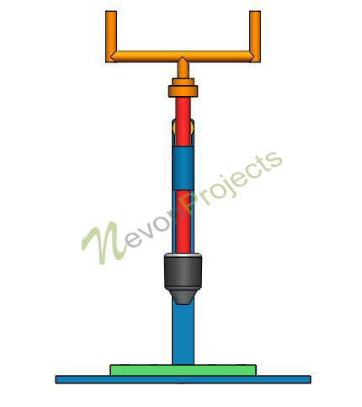
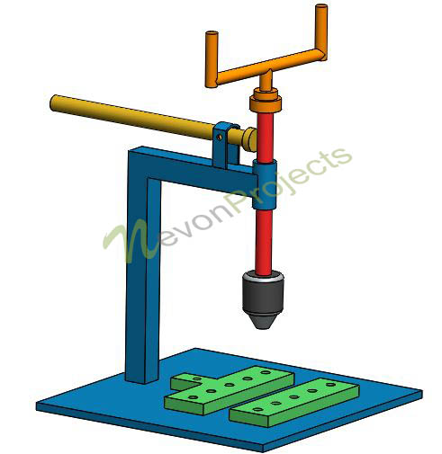

Components
- Shaft
- Spindle Shaft
- Bearing
- Mounts
- Pipe
- Tap Holder
- Machine Bed
- Bench Holder
- Supporting Frame
- Screws & Joints

Advantages
- Aligned Tapping
- Accurate Threading Results
- Easy To Operate
- Faster Operations

